

**JAI SHRIRAM ENGINEERING COLLEGE TIRUPPUR – 638 660**

Approved by AICTE, New Delhi & Affiliated to Anna University, Chennai Recognized by UGC & Accredited by NAAC and NBA (CSE and ECE)

**DEPARTMENT OF**

**ELECTRONICS AND COMMUNICATION ENGINEERING**

**IBM - Naan Mudhalvan**

**Internet of Things – Group 3**

**Phase 4 – Development Part 2**

**PUBLIC TRANSPORT OPTIMIZATION**

**NAME : Selvapriya S NMID :AU711221106031**

**YEAR : III**

**PUBLIC TRANSPORT OPTIMIZATION**

**Development part 2**

# INTRODUCTION:

**Connected Vehicles**:

Equipping public transport vehicles (buses, trains, trams) with Iot sensors and devices allows for real-time monitoring of vehicle status, location, and performance. This data can be used for predictive maintenance, ensuring that vehicles are in optimal condition and reducing downtime.

# Smart Traffic Management:

IoT sensors at intersections, traffic lights, and on-road infrastructure can provide data on traffic conditions. Public transport vehicles can then receive real-time traffic updates, enabling dynamic route optimization to avoid congestion and reduce travel times.

# Passenger Counting:

IoT-based sensors can track the number of passengers boarding and disembarking at each stop. This data is valuable for demand prediction, route optimization, and resource allocation.

# Real-Time Passenger Information:

IoT sensors on vehicles and at stations can provide passengers with real-time updates on vehicle locations, arrival times, and any delays. Passengers can access this information through mobile apps or digital signage.

# Automated Fare Collection:

IoT-enabled ticketing and payment systems can streamline fare collection processes, making it easier for passengers to pay and reducing the risk of fare evasion.

# Security and Surveillance:

cameras and sensors can enhance security on public transport vehicles and at stations. These devices can provide real-time monitoring and alert authorities to any suspicious activity.

# Environmental Monitoring:

sensors can measure air quality, noise levels, and other environmental factors, helping public transport authorities track and mitigate the environmental impact of their services.

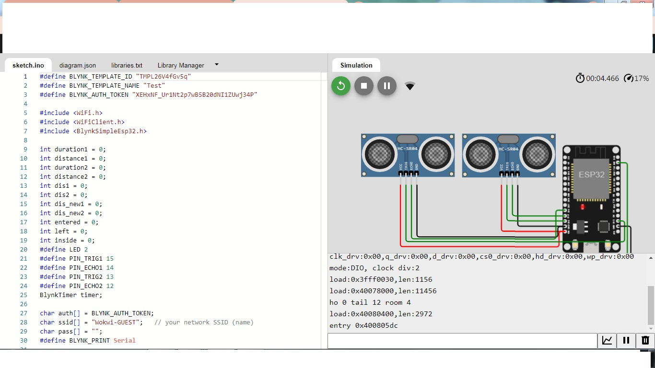

# PROGRAM:

fine BLYNK_TEMPLATE_ID "TMPL26V4fGv5q"

#define BLYNK_TEMPLATE_NAME "Test"

#define BLYNK_AUTH_TOKEN "XEHxNF_Ur1Nt2p7wB5B20dNI1ZUwj34P"

#include <WiFi.h> #include <WiFiClient.h>

#include <BlynkSimpleEsp32.h>

int duration1 = 0; int distance1 = 0; int duration2 = 0; int distance2 = 0; int dis1 = 0;

int dis2 = 0; int dis_new1 = 0; int dis_new2 = 0; int entered = 0;

int left = 0; int inside = 0;

|  |  |  |
| --- | --- | --- |
| #define  #define | LED 2  PIN_TRIG1 | 15 |
| #define | PIN_ECHO1 | 14 |
| #define | PIN_TRIG2 | 13 |
| #define | PIN_ECHO2 | 12 |

BlynkTimer timer;

char auth[] = BLYNK_AUTH_TOKEN;

char ssid[] = "Wokwi-GUEST"; // your network SSID (name) char pass[] = "";

#define BLYNK_PRINT **Serial**

long get_distance1() {

// Start a new measurement: digitalWrite(PIN_TRIG1, HIGH); delayMicroseconds(10); digitalWrite(PIN_TRIG1, LOW);

// Read the result:

duration1 = pulseIn(PIN_ECHO1, HIGH); distance1 = duration1 / 58;

return distance1;

}

long get_distance2() {

// Start a new measurement: digitalWrite(PIN_TRIG2, HIGH); delayMicroseconds(10); digitalWrite(PIN_TRIG2, LOW);

// Read the result:

duration2 = pulseIn(PIN_ECHO2, HIGH); distance2 = duration2 / 58;

return distance2;

}

void myTimer() { **Serial**.println("100"); dis_new1 = get_distance1(); dis_new2 = get_distance2();

if (dis1 != dis_new1 || dis2 != dis_new2){

**Serial**.println("200"); if (dis1 < dis2){

**Serial**.println("Enter loop"); entered = entered + 1;

inside = inside + 1; digitalWrite(LED, HIGH); Blynk.virtualWrite(V0, entered); Blynk.virtualWrite(V2, inside); dis1 = dis_new1;

delay(1000); digitalWrite(LED, LOW);

}

if (dis1 > dis2){ **Serial**.println("Leave loop"); left = left + 1;

inside = inside - 1; Blynk.virtualWrite(V1, left); Blynk.virtualWrite(V2, inside); dis2 = dis_new2;

delay(1000);

}

}

**Ciruit Diagram**:

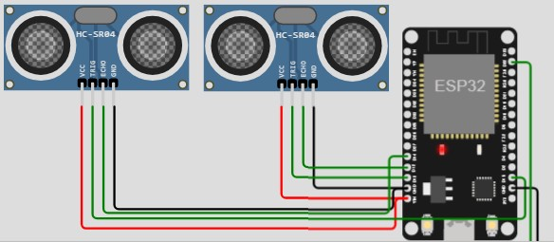

# Smart Infrastructure:

IoT sensors can be embedded in roadways and tracks to monitor conditions, detect maintenance needs, and improve safety.

# Predictive Analytics:

Iot data, combined with advanced analytics, can be used to predict equipment failures, traffic patterns, and passenger demand. This information enables proactive decision- making and service adjustments

# Big Data and Predictive Analytics

Public transportation systems generate large amounts of data. Advanced AI can analyze this data to make predictions about passenger flows, future transportation needs, and potential service disruptions.

# Smart Sensors for Accessibility:

IoT sensors can assist passengers with disabilities by providing information about accessible routes and facilities, ensuring a more inclusive public transport system.

# Integration with Smart City Initiatives:

Public transport IoT data can be integrated into broader smart city initiatives to enhance urban planning and transportation management.

# Environmental Impact Reduction:

AI can optimize routes and schedules to reduce fuel consumption and emissions, contributing to more sustainable and environmentally friendly public transportation.

# Mobility as a service(Maas):

Integrating various modes of public and private transportation through Iot based platforms ,allowing passengers to plan, book, and pay for their journeys.

# Demand responsive transit(DRT):

Implementing Iot technology to create flexile and on demand transit services that adapt to passenger demand, reducing routes and increasing efficiency

Iot technology for public transport optimization is a transformative approach that can enhance the efficiency, reliability and overall quality of public transportation systems.By collecting real time data, predictive maintenance and promoting efficiency contributes to a better experience.